As we’ve seen in Logistic Reg, SVM, KNN that we need to do standardization in order to bring all the feature on same scale, because in all the methods we were finding distance, and whenever we find distance, they should standardized.

But as in decision we are nowhere finding distance, we are just ordering data, and performing split on them so in DT we don’t need to any of the standardization or normalization.

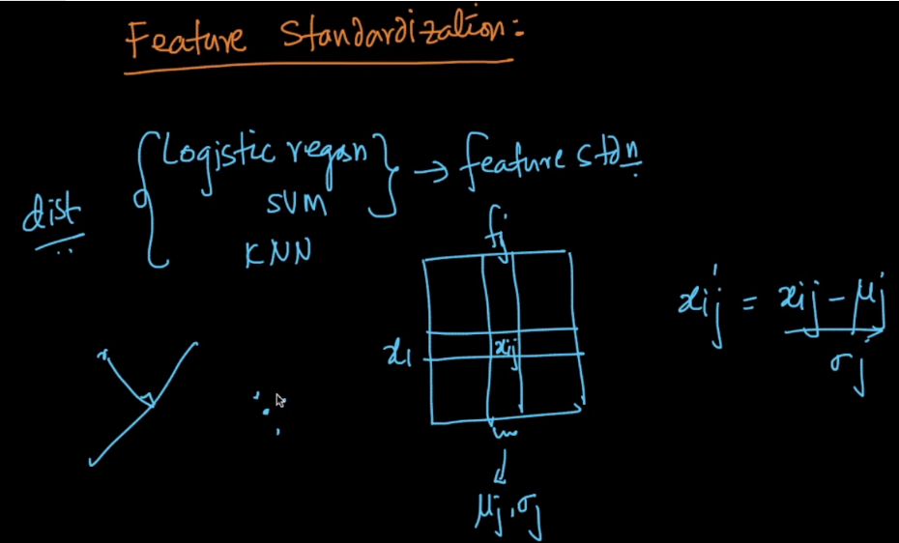

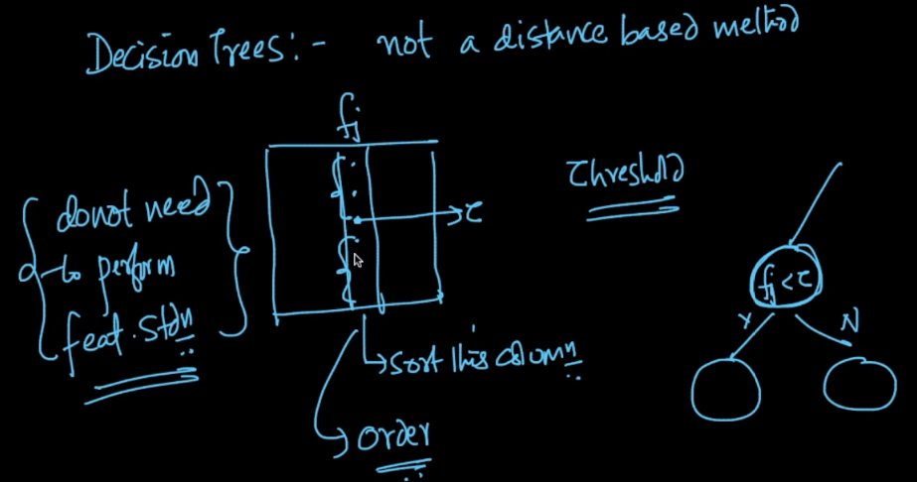

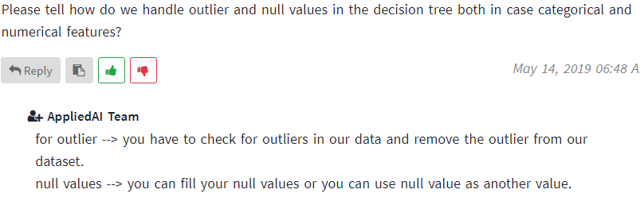

Various ways to perform encoding: <https://towardsdatascience.com/smarter-ways-to-encode-categorical-data-for-machine-learning-part-1-of-3-6dca2f71b159>

Why tree based model performs bad with one hot encoding: <https://towardsdatascience.com/smarter-ways-to-encode-categorical-data-for-machine-learning-part-1-of-3-6dca2f71b159>